Name of the project:

Name of the applicant:

Unit/Institute:
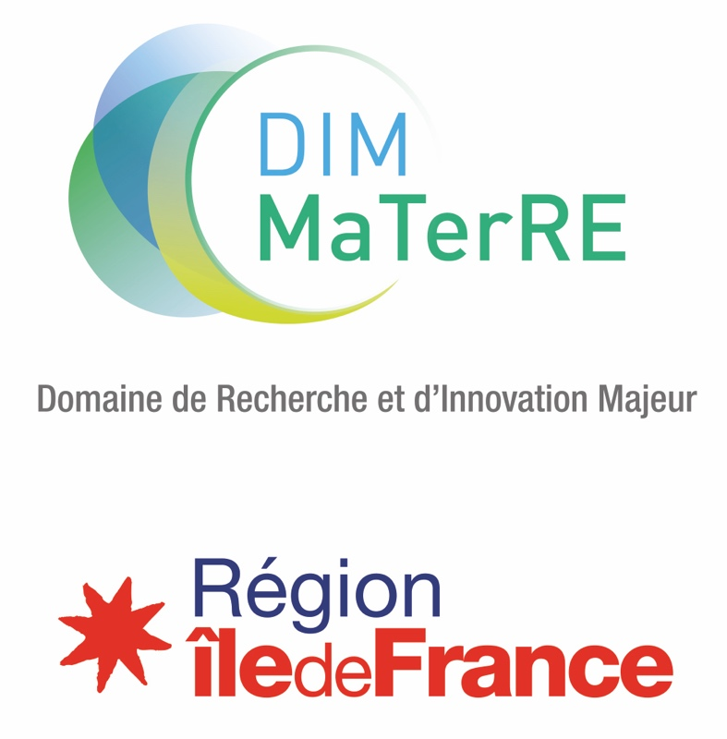

2024 CALL FOR PROPOSALS
Platforms / Federative Equipment

Deadline: 22th April 2024 at 23:59.

Files should be submitted on the dedicated platform at the following address: https://materre-2024-2.sciencesconf.org/

Contact : dim-materre@espci.psl.eu
ELIGIBILITY
Eligible projects are carried out between team members of MaTerRE and the project leader must be from the Ile de France region. Any Ile de France lab is eligible, without prior affiliation to the DIM. The submission of a project will be considered as an application for affiliation to the DIM.
The total cost of the project must be less than € 2 000 000 (pre tax cost). MaTerRE’s contribution can’t exceed 66% of the total cost (whichever amount is inferior).
New equipment and/or upgrade of existing ones are eligible as long as it meets the criteria of the call for proposals.
To be considered eligible, a project must include: this form fulfilled and signed; resume of each project leader (from each partner involved in the project); at least one quote; at least one illustration for communication purpose; if applicable, an affiliation form completed (for each team involved in the project that is not affiliated yet).
THEMES
The DIM MaTerRE is centered around four thematic axes, corresponding to current scientific, technological and societal challenges:
  - Capture, Production and Valorisation of strategic gases (CO₂, H₂…).
  - Eco-compatible Energy Storage or recovery.
- Construction materials.
  - Recycling, eco-design, sustainable materials, urban mining.
This is complemented by 5 transverse methodological axes, including High-throughput methodologies (microfluidics…), Architected and multiscale materials, Advanced characterization techniques, numerical methods (databases, artificial intelligence, numerical modelling, simulations…), Economics of the energy transition.
Proposals funded by MaTerRE have to fit within at least one, preferably two, of these axes.
EVALUATION CRITERIA
The evaluation criteria are the following:
  - Novelty and quality of the collaboration, in terms of complementarity and expected synergy. The project must associate the skills of at least two laboratories relevant for MaTerRE.
  - Scientific and technical quality of the project.
  - Innovative aspect of the project
  - Quality of the cofinancing plan and quality of the environment of the project;
  - Accessibility for Ile de France researchers and especially MaTerRE members: once purchased, clear rules to access to the equipment/platform must be defined and accessible to all.
  - Federative and structuring effect for the network and Ile de France Region.

For shared platforms and equipments, academic/industrial collaborations will be encouraged. (to be specified by support letters).

CALENDAR
22nd April 2024 at 23:59: Deadline for proposal submission (https://materre-2024-2.sciencesconf.org/).
28th June 2024 Panel review of the preselected project leaders.
Early july 2024: Publication of the results. Final decision will depend on regional allowance.

LANGUAGE & FILE NOMENCLATURE
Projects must be written exclusively in English.
Files must be named according to the following these rules: PROJECTSHORTNAME_PROJECTLEADERNAME_FILENAME.

IDENTIFICATION OF THE PARTNERS

 | Lab name, number and address | Team name | Name (first, last) of the project leader | Email | Phone number
Leader
Partner 1
Partner 2
…
Please attach a short resume (max 1 page, including experience, expertise, responsibilities, list up to 5 recent publications, main projects…) of each project leader (from each partner team)

Please highlight what makes the project innovative and federative (maximum 5 lines).

Please highlight the novelty and impact of the proposed project

List up to 5 major publications in the field, not necessarily from your teams (DOI link mandatory)

List of publications

Team members involved in the project

 | First names, Names | Emails
Leader
Partner 1
Partner 2

Thematic or transverse axis or axes concerned

Thematic axes

☐ Strategic gases

☐ Eco-compatible energies
☐ Construction Materials
☐ Recycling, eco-design, sustainable materials and urban mining

Transverse axes

☐ High-throughput

☐ Architected and multiscale Materials

☐ numerical methods

☐ Advanced characterization

☐ Economics

SCIENTIFIC DESCRIPTION OF THE PROJECT
(3 pages, Times 11)
Title of the project
Key Words
Public summary (for communication purpose) in French and in English
For communication purpose, join as attachment a 300 dpi graphical illustration to the proposal.
Scientific description of the project; state of the art, innovative character, risks and mitigation plan, expected results

Added value of the equipment for each partner team
Partner 1

Partner 2

Structuring effect
Access conditions for non-partner teams (MaTerRE and Ile de France teams and labs/ other labs/ Industrial partners)
Use of the equipment after MaTerRE

Adequacy to the objectives and integration to the MaTerRE project
Added value for Paris Region
Please indicate the expected impacts if the objectives are reached, and the collaborations established in Paris Region

Installation and accessibility time frame

FUNDING SCHEME
Enclose at least one quote (except for internal development)

Host institution in charge of the management of the equipment and its maintenance.

Location of the equipment
Lab
Site

Budget
Detailed budget

Category | Amount
 | - €
 | - €
 | - €
 | - €
Total | - €

Envisioned project co-financing.
Please indicate the amount and % of the total cost for each sponsor. If possible, and if the project is pre-selected, engagement letters should be presented for the auditions.

Heading | Acquired | Submitted | % of the total | Amount
MaTerRE* |  | X | [66% max] | - €
Cofunding 1 : |  |  |  | - €
Cofunding 2 : |  |  |  | - €
 |  |  |  | - €
Total cost |  |  |  | - €

*Ile de France Region maximal rate : 66%

EVALUATION

Suggested experts for peer review (from outside Paris Region, without common publications with any of the project partners during the past five years)

Unwanted experts (argue)

SIGNATURES

Signature of the project leader

First name, Last name
Position
In
The

Visa / Signature of the unit director
First name, Last name
Position
In
The
Signatures are required for the proposals to be accepted.

ANNEX: GENERAL RULES OF THE CALL FOR PROPOSALS MATERRE

Advertency: These rules are likely to be enriched or clarified, on the basis of Region rules, between now and the award of projects.

The objective of MaTerRE is to generate breakthroughs in sustainable materials for the energy transition, both fundamental and applied, by promoting interactions between specialists from different disciplines.
The aim of the call for proposals is to promote innovative, disruptive projects by creating synergies between laboratories.
All the teams working in the fields listed in MaTerRE are eligible to respond to the call for proposals (CFP).
In the case where a team applies for several proposals, MaTerRE requests that the unit director establishes a ranking of the proposals.
The proposals will be selected in a two-stage process:
- Preselection based on the submitted document.
- Selection after audition of the project leader.
The selection of proposals will be organized by MaTerRE's steering committee, supported by a jury including experts from outside the IDF region.

FINANCING
The costs of installation or work, the guarantee - to be provided during the purchase and included in the invoice - are eligible for funding.
The recipient institution agrees to maintain financed equipment.
Any management costs of the beneficiary institutions are not eligible for funding.
The letter of commitment of the co-funder(s) should be presented during the auditions.
The beneficiary institution must be a non-profit organization. However, industrial cofunding is encouraged. In this case, a partnership contract should set terms of access. Host institution is free to decide of the type of partnership contracts.

ENGAGEMENT OF THE TEAMS

The recipient teams of a grant of the Île de France Region, within the framework of a MaTerRE Call for Proposals, commit to, in particular:
- To read and respect the regional and MaTerRE rules.
- To transfer the progress report (s), the activity report of the project or any other document at the request of the administrative department of the ESPCI, MaTerRE's managing institution, respecting the indicated deadlines and document formats.
- To indicate, in the context of any written publication (article, proceedings ...), the following thank-you text: "This work has been sponsored by the Ile-de-France Region in the framework of MaTerRE”.
- To display, as part of any oral communication (conference, seminar, workshop, school ...) the logo of the Ile-de-France Region and that of MaTerRE and its guardianships.
- To invite a representative the Ile de France Region and of MaTerRE for any inauguration of equipment over 100k€.

DATA MANAGEMENT

In accordance with Article 13 of the Regulation of the European Parliament and of the Council on the protection of individuals with regard to the processing of personal data and on the free movement of data, and repealing Directive 95/46/EC - Personal Data Protection Policy, the purpose of this policy is to inform you about the processing of personal data that you share with us.
Type of data collected: Only personal and non-sensitive data are collected.
Personal data communicated through the project deposal or affiliation form will be used by MaTerRE instances in order to communicate about DIM MaTerRE actions. These personnal data could be communicated to experts to perfom the evaluation of your project. Experts will delete all your personal data at least one month after the end of the evaluation.
If you submit a proposal, we may also contact you to ask for complementary information or give you information about the steps of the call for proposals.
Data will be conserved for the duration of the program. At any moment, you can contact dim-materre@espci.psl.eu to modify or erase your information.
In accordance with the general data protection regulation (EU) 2016/679, to data processing, files and freedoms, you have the right to access, rectify, delete your personal data, to request its portability, or to limit its processing.
In the case your project receive funds from DIM MaTerRE through a call for proposals, we may also contact you for all requirements linked to the project (administrative, communication, scientific purposes). As DIM MaTerRE is funded by Ile de France Region, we will communicate your information to the research department of Ile de France Region in the framework of DIM MaTerRE program management and reports. In that case, your data will be conserved for the regional contract duration (10 years). At any moment, you can contact dpo@iledefrance.fr and dpo@espci.psl.eu to modify or erase your information.

See details in annex.
Details about data management (RGPD/GDPR policy) in annex

